**Potential Topics / Question Types**

* Writing simple C programs, with good styling.
* What is ARGC and ARGV?
* Learn more about compiling command
* **Learn LOTS about POINTERS**
  + Difference between char message[] = “Tree” and char *message = “Tree”
  + [[ANSWER IS HERE]](https://www.openlearning.com/courses/Comp1917Rag?inCohort=courses/Comp1917Rag/Cohorts/ClassOf2016#comment-575828bbba5e654ad9b25681)
* Learn about the HEAP and STACK
  + <http://cs-fundamentals.com/c-programming/memory-layout-of-c-program-code-data-segments.php>
* Learn SWAP3NUMBERS function.

**Unknown Questions**

2009 Past Paper

* Question 4
* Question 5

2013_S2 PAST PAPER

* Question 6

**Questions to revise**

2009 Past Paper

* Question 6 🡪 Recursion? Not sure if we can be tested on that.

**THEORY 2014 S1 EXAM**

Highlight – UNSURE

(0) A  
(1) C  
(2)   
(3) z = 6  
(4) C  
(5) value = 4  
(6) B  
(7) To add in increasing order by 1 additional value each time (e.g 1 + 2 + 3 + 4 + 5 . . .) up to N numbers.  
(8)   
int values [LENGTH];  
int oldLeft = values[0];  
int j = 0;  
while (j < LENGTH) {  
 values[j] = values[j + 1];  
 j++;  
}  
values[LENGTH - 1] = oldLeft;

(9)   
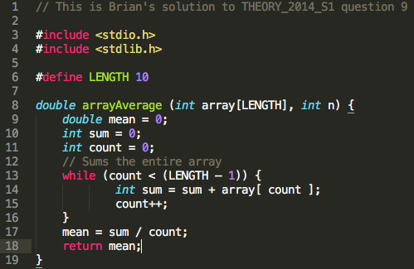

(10) Lack of using new line character “\n” in the printf statement. It should be printf (“%c**\n**”, draw);  
DON’T KNOW PART #2

(11) DON’T KNOW

(12) DON’T KNOW – TAKE A SECOND LOOK LATER

(13) DON’T KNOW

(14) DON’T KNOW – Do we need to remember specific instructions of each microprocessor?

PART C  
(15) Need to do encryption / decryption exercises  
(16)